PROJECT MANAGEMENT

PLAN

For

Homework Tracker

Homework Tracker:

Alex Sweeney

Eman Khan

Donovan Byler

William Oeffner

# Revision History

*A - ADDED M - MODIFIED D – DELETED

|  |  |  |  |  |  |
| --- | --- | --- | --- | --- | --- |
| VERSION NUMBER | DATE | NUMBER OF FIGURE, TABLE OR PARAGRAPH | A* M D | TITLE OR BRIEF DESCRIPTION | REVISED BY: |
| 1 | 02/04/21 | ALL | A | Initial Outline | Whole Team |
| 1.1 | 02/09/21 | 4.1 | A | Added Gantt Chart | Donovan |
|  |  |  |  |  |  |
|  |  |  |  |  |  |
|  |  |  |  |  |  |
|  |  |  |  |  |  |
|  |  |  |  |  |  |
|  |  |  |  |  |  |
|  |  |  |  |  |  |
|  |  |  |  |  |  |
|  |  |  |  |  |  |
|  |  |  |  |  |  |
|  |  |  |  |  |  |
|  |  |  |  |  |  |

# 

# Table of Contents

**Revision History** **2**

**Table of Contents** **3**

**Project Summary** **4**

Purpose, Scope, and Objectives 4

Assumptions and Constraints 4

Project Deliverables 4

Schedule and Budget 4

**References** **4**

**Roles and Responsibilities** **4**

**Managerial Processes** **4**

Project Estimation Plan 4

WBS and Work Packages 4

Schedule Dependencies 4

Requirements Control Plan 4

**Risk Management Plan** **4**

**Product Acceptance Plan** **4**

# 

# Project Summary

## Purpose, Scope, and Objectives

The goal of this project is to create a web application that allows people, primarily students, to manage their time efficiently and track and plan out their homework and other tasks.

Users will be able to enter in tasks, mark when they are due, tag them with a category and plan when to complete them.

We plan on building in a list of all Kent State University classes as tags to simplify the process for Kent State Students.

## Assumptions and Constraints

We assume the users of this application will be able to access a web-based application, allowing them to use our application. We plan to support both desktop and mobile browsers for this.

Our biggest constraint with this project would be the time available to complete it.  
We have less than 13 weeks to create a deliverable, without spending a full-time amount of work on it.

## Project Deliverables

The minimum set of deliverables we plan for are as follows:

* A web-based app where users can add tasks
* Users will be able to mark due dates for each task
* Users will be able to add a tag to mark the category of the task and the class, if applicable
* Users will be able to assign a priority to their tasks
* Users will be able to view a list of their tasks
* Users will be able to view a calendar view of their task
* Users will be able to mark when their tasks are completed

## Schedule and Budget

For this project, we have a maximum 13 weeks from start to finish, including planning.

Due to lack of external funding, we are using freely available resources to complete our project.

# References

# Roles and Responsibilities

* Alex
  + App Hosting Platform
    - They will maintain the Firebase Hosting platform and facilitate the necessary tasks to administrate it
  + Database design and administration
  + Source code control
    - Monitoring the pushes to the code repository
    - Merging pull requests into our main branches.
* Donovan
  + Coordinating and designing our plans and processes for the development of our app
  + Technical lead on the front-end development
  + Drafting of UI and UX design
  + Uploading project documents and assignments to Blackboard
* William
  + Backend development
  + Creating a web scraper through Python
  + Assisting website development team as needed
* Eman
  + Backend development
  + Use Node.js for writing back-end API services
  + Helping with testing and design development when required

# Managerial Processes

## Gantt Chart

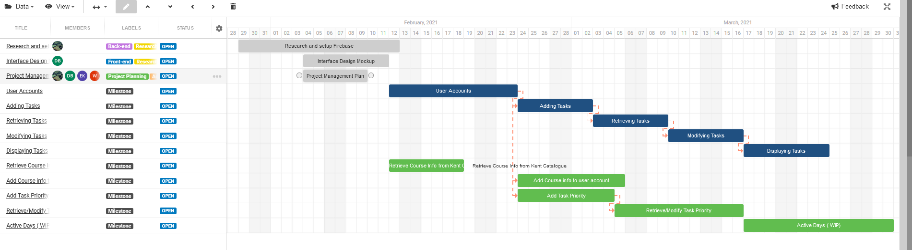

[Gantt Chart](https://trello.com/b/37bE0DaK/agile-sprint-board)

## Project Estimation Plan

The project is estimated to be completed within 12 weeks. The base functionality of the program will be completed first.

We created a Gantt chart with the critical path and secondary functions listed along with an estimation of how long each milestone would take to complete.This chart will be revisited on a bi-weekly basis and adjusted accordingly.

We have reviewed the technologies we need to complete the project, and we feel confident that our estimation of technological complexity will be accurate.

## Work Breakdown Structure

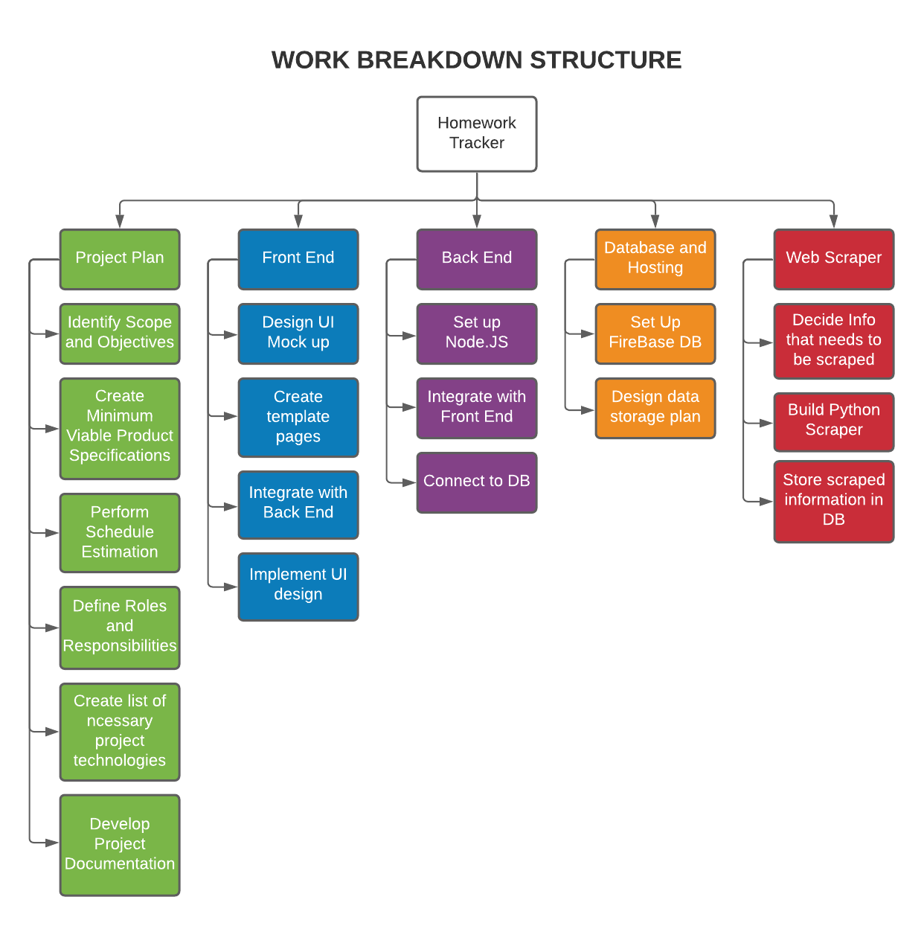

## Schedule Dependencies

Our Gantt chart has dependencies noted with an orange dotted line to indicate milestone dependencies on the previous task. Our critical path must be completed in this order, though subsequent tasks may be worked prior to the completion of the previous milestone. All of our scheduling dependencies come from our software development and are not dependent upon any outside source.

## Requirements Control Plan

## We have clearly defined our critical path which must be completed for product viability. Our primary resource concern is time. Each week we will ensure that our schedule remains viable and accurate. Our secondary features will be added if there is an adequate amount of time remaining, though the scope of the project is not likely to change much.

## We will use Github’s branching features to ensure version control and organize our development. There will not be direct commits to the main branch until the feature is in working condition.

# Risk Management Plan

Within the project we will have a test suite which can be run on the code in order to determine if it is running at the appropriate level. In addition to this we have an automated test set up within our repository that will prevent any code that can’t be compiled from being pushed to the repository. This will also be accompanied with our current plan which will reduce the risk of a product not being shipped by shifting all parts of the critical path to the start of production, and it will allow us to also identify any required changes early. This will reduce the risk of losing great amounts of time and money due to any oversights in the planning process.

Risks within our scheduling will also be avoided using a timekeeping software with set end dates for each task being stated, and we have people specialized within each area focusing on a single task at a time. If anybody were to get into any unforeseeable events then we have also scheduled some time near the end as free time to polish the project that is in reserve to help keep the project on our intended schedule.

If an issue were to occur then we will develop contingency plans through remote discussions at the moment the event occurs. This will allow everyone to have input on the appropriate way to approach the situation, and it will allow the best solution at the time to be acted upon immediately.

# Product Acceptance Plan

Project/System Information

Project Objectives

To create a system that uses information entered by the user (student) and display it in the form of a checklist including task fields and tags for easier accessibility with regard to a time frame.

System Description

The tasks will show up in the order of the deadline and will be available under the specific tag (for example, a specific course). The student will be able to check the completed tasks and they will be archived for later accessibility if needed.

References

IEEE Standard for Software Project Management Plan is used for the project documentation.

Outstanding Issues

Time is the greatest constraint we have, as we need enough time to build the web application and have it pass acceptance testing.

Roles and Responsibilities

Alex will ensure the functionality and testing of App Hosting Platform, as well as the database design, and source code control.

William will ensure functionality of the web scraper and web development.

Donovan will ensure the layout of UI and UX design.

Eman will ensure Javascript and node.js codes are functional.

Test Plan

Scope

We will test how the tags are working with relation to the tasks, the functional capability of the student check marking from the list, the response of the system when a task undergoes a modification or deletion, and the order in which the tasks are displayed.

Testing Approach

We will perform functional testing, compliance testing, as well as capacity testing at the system level as well as integration level. We will use Agile testing methodology, testing the features as they are developed to ensure good quality.

Test Environment

Modern operating system

Windows 8 and above

Pre-testing phase:

Test plans document.

Test cases documents

Test the design specifications.

Test phase:

Test using Tool Simulators, with Data, as well as using the Trace-ability Matrix

Post-test phase:

Test Results/reports

Defect Report

Installation/ Test procedures guidelines

Release notes